## Title:

Rebuttal to Frank et al 2016

## Authors:

NAFC1Montevecchi WA2  
Robert D3  
Davoren GK4  
Rose G5?

## Affiliations:

1. Northwest Atlantic Fisheries Centre, Fisheries and Oceans Canada, St. John's, NL, Canada
2. Cognitive and Behavioural Ecology Programme, Departments of Biology and Psychology, Memorial University of Newfoundland, St. John’s, NL, Canada
3. Institut des sciences de la mer, Université du Québec à Rimouski, Rimouski, QC, Canada
4. Department of Biological Sciences, University of Manitoba, Winnipeg, MB, Canada
5. CFER/ UBC ?

## Abstract

Capelin acoustic indices

In the absence of an absolute abundance estimate for the 2J3KL capelin, researchers in recent years have utilised an abundance index generated from a spring acoustic survey of the stock (see table 1, Frank et al 2016, Mowbray, 2014). However, this survey has limited spatial coverage. At the time of the inception of NW Atlantic acoustic surveys for capelin, the NAFO Division 2J3KL (2J3KL) stock was considered to be two stock stocks, one in the northern portion (2J3K) and one in the south (Campbell and Winters, 1973) . Consequently acoustic surveys were designed to assess the two “stocks” separately: a spring (May) survey timed to intercept 3L capelin during spring feeding, just prior to their spawning migration; and a fall (Oct-Nov) survey of the 2J3K portion, as ice coverage precluded surveying this area in the spring. Later, in light of evidence from meristic and tagging studies (Misra and Carscadden, 1984 and Nakashima, 1992 ) stock definitions were amended and 2J3KL has since been considered a single stock unit. More recently mitochondrial DNA studies (Kenchington 2015), suggest that the stock boundaries may be broader still with no significant differences evident among beach spawners from Divisions 2J3KL , 3Ps and Scotian Shelf.

This evolution in stock definitions has resulted in surveys which do not provide synoptic coverage. One issue arising from the incomplete coverage can be demonstrated using capelin catch at age information from a fall random stratified bottom trawl survey which has been conducted in Div 2J3KL using a Campelen 1800 trawl since 1995. Since catchability of pelagics fish in bottom trawls is negatively impacted by fish density, vertical migration and the presence of demersal predators (McQuinn 2009) abundance estimates from this survey cannot replace an acoustic survey estimate and the data serve only a coarse estimate of even behavioural characteristics such as distribution. However, multiyear trends in the bottom trawl survey index have been shown to trend in the same direction of those from the spring acoustic survey (Fig FM1) and catches from bottom trawl surveys are used elsewhere to describe capelin distribution (Grégoire et al, 2013 ). We have used bottom trawl catch to examine age dependent distribution. Bottom trawl survey catch at age was calculated by applying age-length keys generated for each NAFO division to the extrapolated length frequency of capelin within each division. Results indicated a latitudinal cline in age composition with the youngest capelin in the south and the older ages more prevalent in the northern divisions. These age dependent distributions are consistent between periods of low (2002-2004) and moderate (2013-2015) acoustic survey abundance, although a larger proportion of age 1 fish are present in 3L during the low abundance period (Fig FM2). Unfortunately prior to 1991, when capelin were most abundant, the fall bottom trawl survey employed an Engels trawl which retained few capelin so a similar analysis could not be conducted. However, the age distribution from the fall 2J3K acoustic survey are available for this period. While the acoustic survey is limited as it was only extended to include 3L following the collapse, it still provides a similar picture of latitudinal cline in age during both high and low abundance periods within the surveyed areas.

This age dependent distribution presents issues for the use of both spring and fall acoustic survey results as abundance indices. During spring acoustic surveys age 1 capelin (hatched the previous summer), present such a weak acoustic signal that they are only detected in the survey when present in large numbers and high densities. This age group is also poorly retained by the sampling gear employed (Diamond IX and Campelen trawls) resulting in an underestimation of its contribution to the acoustic signal. Older capelin (ages 3 and older) which have overwintered as age 2+ in 2J3K may not have entered the survey area, and even if passing through are unlikely to be detected due to their high level of aggregation relative to the survey effort. Capelin surveys in other countries are timed to avoid spawning migrations. An exception is Iceland, where if capelin are not discovered in surveys during the fall feeding period, as may occur as a result of shifting stock distribution, follow-up surveys are conducted during spawning migrations (Carscadden et al 2013). Recognizing the difficulty of locating highly aggregated spawning shoals in a large expanse of water the survey effort is increased and commercial fleet information used to exclude areas with no capelin, allowing the survey vessel to do a more concentrated survey on the highly aggregated schools of migrating capelin in areas where they were detected. As this level of survey effort is not possible during the Newfoundland 3L spring survey these migratory older spawners are rarely intercepted with the abundance composed primarily of age 2 capelin, providing an index immature fish (Fig FM-3).

Frank et al. (2016) considered that delays in the timing of capelin spawning may have led to a mismatch in capelin availability to the survey. However since immature capelin contributed 60-89% of the abundance in the pre-collapse period, and the abundances of immature and maturing capelin are highly correlated throughout the time series (R2=0.98, P<0.001) this is highly unlikely. It could however be argued that the larger proportions of maturing age 2 fish in the survey area following the collapse may have been more mobile than their immature counterparts contributing to the prolonged period of depressed values. However repeat surveys conducted approximately one month after the regular time period surveys in both 1991 and 2003 failed to detect a marked change change in biomass between surveys).

Consequently we find no evidence that a delay in the migration of spawning fish is responsible for the sudden and sustained loss of capelin in spring surveys conducted by Canada and the USSR. Neither would it explain the coincidental sudden decline of capelin in the fall acoustic surveys which first occurred in 1990, a year when spawning timing was normal (Fig FM-4).

Changes in capelin distribution have been documented to occur in tandem with changes in stock abundance and environmental conditions in both Iceland and Barents Sea capelin stocks (Carscadden et al 2013). These changes are best documented for the fall feeding period of these stocks (Ingvaldsen and Gjoesater 2013) although Icelandic capelin feeding north of Iceland have been documented to use a route passing on the eastern side of the island most years, but occasionally passing on the western side in both cases following bathymetric and temperature profiles while minimizing predation by cod (Olafsdottir and Rose 2012). In neither of these cases have these oceanic migratory stocks been known to fail to conduct a feeding migration post spawning (Carsacdden et al 2013). Frank et al. have suggested that an alternate explanation of the capelin survey index collapse was an abrupt change in capelin migration patterns, with capelin remaining inshore year around. As evidence for this hypothesis they point to westerly, inshore shifts in the center of concentration as calculated from the fall bottom trawl surveys between the 1996-2010 period relative to 1985-1995 . However their own annual mappings demonstrate the high degree of interannual variability within the earlier period of high acoustic abundance, with inshore distributions occurring in three of the years with the highest abundance index the following spring (1986-1988, Fig S2 Frank et al).

This hypothesis was also explored using data from the spring survey. If post spawning capelin remained in the embayments year around as postulated, or had undergone an inshore shift in distribution, we would expect to see a change in the ratio of immature to mature fish in the surveyed strata. Yet the proportion of immature fish differ significantly over the period of the decline (1985-1992). Aaron can you provide stats please?), although the proportion of maturing fish offshore increased in all areas (Fig FM-5).

From 1967-1968 seasonal surveys of capelin were conducted in Trinity Bay, an important capelin spawning area (Winters 1970). These surveys revealed overwintering mature capelin near bottom in depths from 140 -200m. They also revealed large schools of immature fish. Although the amounts of capelin present were not quantified, Winters suggested that adequate numbers might be present to support a winter trawl fishery. From 2002 another series of seasonal acoustic surveys (January, June and September) were conducted. (Table). Surveys were conducted from a 23 m inshore research vessel (CCGS Shamook) using a calibrated EK500 ecohosounder with a towed 38 kHz transducer. Surveys followed a fixed transect design and covered both the main portions and the four arms of Trinity Bay (Fig FM-6 ). When acoustic targets were encountered, sampling was conducted using bottom and midwater trawls, targeting the portion of the water column where the acoustic signal occurred. The lack of fishable aggregations of capelin precluded extensive sampling but samples were obtained from most aggregations. (Table ). Length, sex and maturity stage were recorded for all fish sampled and ages determined for two fish per sex per 0.5 cm interval.

Despite the paucity of samples, there was considerable seasonal consistency in annual trends in composition. A mix of immature (age 1) and maturing fish (ages 2 and 3) were present in the bay from January – September. By October nearly all maturing and post-spawning capelin had left the bay. Over 50% of the overwintering fish present in January were the previous years hatch (now age 1), with equal parts two and three year olds maturing for the first time (Fig FM-7). The relative contribution of older maturing fish increased through the spring with peak abundances observed in June as maturing fish migrated into the Bay (Fig FM-8). By October, age 1 fish again dominated the catch as the older spent fish retreated from the bay. Spatial patterns in age composition were similar to those patterns reported by Winters with older larger capelin overwintering in the main portion of the bay while juvenile capelin were more prevalent in the inner arms (Do we want maps?). In all months except June capelin were aggregated along the sides of the trench around 200 m depth, whereas in June they present in the arms and in shallower water closer to shore at the bottom of the bay.

In addition to the small vessel survey of Trinity Bay, it was also added to the annual 3L spring offshore survey starting in 1999 and has been covered as part of this annual survey in all subsequent years except 2014 and 2015 (Mowbray 2014). The biomass of capelin in Trinity Bay in May was not significantly correlated with that in the offshore, although the relative contribution in the Bay increased markedly in years of very low offshore abundance such as 2010 ( Fig FM-9).

In addition to occupations of Trinity Bay, Conception Bay (XXXX), Notre Dame Bay (1999) and Bonavista Bay (XXXX) have also been surveyed opportunistically during the offshore survey when time permitted. Although these occupations were not appropriate for the production of a biomass estimate, a variety of habitats within each Bay were investigated and no large densities of capelin observed.

Ingvaldsen and Gjøsæter (2013) found that while the potential area of distribution of capelin in the Barents has been linked to ice coverage and sea temperature, the amount of the area utilised was proportional to stock size. They suggest that by increasing the area of occupation capelin in the Barents Sea were better able to meet their food requirements. Frank et al. failed to find a similar relationship for the 2J3KL capelin stock using an area of occupation calculated from the fall bottom trawl surveys. This finding is not surprising. McQuinn (2009) found that in the absence of Atlantic cod predation, Atlantic herring in the Gulf of St. Lawrence moved into the suprabenthic zone, increasing their availability to the bottom trawl despite declines in abundance. Similarly, Mowbray (2002) found that capelin were closer to the seabed when cod were not present. Consequently as cod abundance declined in the late 1980s, the portion of capelin biomass in the trawl zone (bottom 4 m of the water column) would have increased, increasing the availability to the bottom trawl. Moreover, Mowbray (2002) also found that capelin in low densities were in closer association with the bottom and displayed less vertical movement than when densities were high. Another factor which may have caused a persistence of capelin in bottom bottom trawl catches in the face of declining capelin abundance.

It should be noted that distribution changes associated with the survey index collapse included vertical movements as well as horizontal displacements. This change in vertical distribution is a cause for concern when conducting acoustic surveys. A limitation of acoustic surveying is the inability to resolve targets on or near the seabed, an area commonly referred to as the bottom deadzone (Ona and Mitson ). The height of the deadzone is a function of the pulse length and frequency of the acoustic system used. In the case of the capelin acoustic surveys the bottom deadzone was approximately 0.75 m.

In order to address the potential impact of vertical distribution changes on the availability to acoustic surveys dedicated experiments were carried out in 1995 and 1999 and a range of values for diel changes in detectability ascertained (Mowbray, 2014). These values were then used along with the variability in acoustic calibration precision, sampling error of capelin for determination of length for target strength estimation and spatial variability in distribution patterns in the calculation of confidence estimates for each survey since 1988 using a Monte Carlo simulation. Confidence limits generated in this matter indicate a significant decline in capelin biomass between the late 1980s and 1991 (Fig FM-9).

## References

Alheit J, Roy C, Kifani S (2009) Decadal-scale variability in populations. In: Checkley D, Alheit J, Oozeki Y, Roy C (eds) Climate Change and Small Pelagic Fish. Cambridge University Press, Cambridge, UK

Buren AD, Koen-Alonso M, Pepin P, Mowbray F, Nakashima BS, Stenson GB, Ollerhead N, Montevecchi WA (2014) Bottom-up regulation of capelin, a keystone forage species. PLoS ONE 9:e87589

CAMPBELJL. , S., AND G. H. WINTERS1. 973. Some biological characteristics of capelin, ***Mullotus vilkosus,*** in the Newfoundland area. ICNAF Wedb.1973(III): 137-144.

Carscadden JE, Frank KT, Leggett WC (2001) Ecosystem changes and the effects on capelin (*Mallotus villosus*), a major forage species. Canadian Journal of Fisheries and Aquatic Sciences 58:73-85

Carscadden JE, Gjøsæter H, Vilhjálmsson H (2013) A comparison of recent changes in distribution of capelin (*Mallotus villosus)* in the Barents Sea, around Iceland and in the Northwest Atlantic. Progress in Oceanography

Carscadden JE, Nakashima BS (1997) Abundance and changes in distribution, biology and behavior of capelin in response to cooler water of the 1990s. Forage fishes in marine ecosystems Proceedings of the International Symposium on the Role of Forage Fishes in Marine Ecosystems Alaska Sea Grant College Program Rep No AK-SG-97-01. University of Alaska Fairbanks, Fairbanks, Alaska

Chavez FP, Ryan J, Lluch-Cota SE, Ñiquen MC (2003) From anchovies to sardines and back: multidecadal change in the Pacific Ocean. Science 299:217-221

Dalley EL, Anderson JT, deYoung B (2002) Atmospheric forcing, larval drift, and recruitment of capelin ( Mallotus villosus ). ICES Journal of Marine Science 59:929-941

DFO (1994) Report on the status of pelagic fishes (capelin off Newfoundland and in the Gulf of St. Lawrence, and herring off the East, Southeast and South coasts off Newfoundland). DFO Atlantic Fisheries Stock Status Report 1994/3

DFO (2008) Assessment of capelin in SA2+Div. 3KL in 2008. DFO Canadian Science Advisory Secretariat Science Advisory Report 2008/054

DFO (2010) Assessment of Capelin in SA 2 + Div. 3KL in 2010. DFO Canadian Science Advisory Secretariat Science Advisory Report 2010/090

DFO (2013) Assessment of capelin in SA2 + Div. 3KL in 2013. DFO Canadian Science Advisory Secretariat Science Advisory Report 2013/11

DFO (2015) Assessment of capelin in Subarea 2 and Divisions 3KL in 2015. DFO Canadian Science Advisory Secretariat Science Advisory Report 2015/036

Frank KT, Leggett WC (1981) Wind regulation of emergence times and early larval survival in capelin (*Mallotus villosus*). Canadian Journal of Fisheries and Aquatic Sciences 38:215-223

Fisher JAD, Frank KT (2004) Abundance-distribution relationships and conservation of exploited marine fishes. Mar Ecol ProgSer 279:201-213

Frank KT, Petrie B, Boyce D, Leggett WC (2016) Anomalous ecosystem dynamics following the apparent collapse of a keystone forage species. Marine Ecology Progress Series 553:185-202

Gjøsæter H, Bogstad B, Tjelmeland S (2009) Ecosystem effects of the three capelin stock collapses in the Barents Sea. Marine Biology Research 5:40-53

Gomes MdC, Haedrich RL, Villagarcia MG (1995) Spatial and temporal changes in the groundfish assemblages on the north-east Newfoundland/Labrador Shelf, north-west Atlantic, 1978-1991. Fisheries Oceanography 4:85-101

Grégoire F, Girard L, Beaulieu J-L, Lussier J-F, Bruneau, B. (2013) Capelin (Mallotus villosus) in the Estuary and Gulf of St. Lawrence (NAFO Divisions 4RST) in 2012. DFO Can. Sci. Advis. Sec. Res. Doc. 2013/023

Hammill MO, Stenson GB, Doniol-Valcroze T, Mosnier A (2011) Northwest Atlantic harp seals population trends, 1952-2012. DFO Canadian Science Advisory Secretariat Research Document 2011/099

Hutchings JA, Myers RA (1994) What can be learned from the collapse of a renewable resource? Atlantic cod, *Gadus morhua*, of Newfoundland and Labrador. Canadian Journal of Fisheries and Aquatic Sciences 51:2126-2146

ICES (2017) Report of the North Western Working Group (NWWG). Copenhagen, Denmark

Ingvaldsen RB, Gjøsæter H 2013 [Responses in spatial distribution of Barents Sea capelin to changes in stock size, ocean temperature and ice cover](http://www.tandfonline.com/doi/full/10.1080/17451000.2013.775450) [Marine Biology Research](http://www.tandfonline.com/toc/smar20/9/9)Vol. 9, Iss. 9, 2013

Jangaard PM (1974) The capelin (*Mallotus villosus*): biology, distribution, exploitation, utilization, and composition. Bulletin of the Fisheries Research Board of Canada 186:1-70

Kenchington, E. L., Nakashima, B. S., Taggart, C. T., & Hamilton, L. C. (2015). Genetic Structure of Capelin (*Mallotus villosus*) in the Northwest Atlantic Ocean. *PLoS ONE*, *10*(3), e0122315. http://doi.org/10.1371/journal.pone.0122315

Koen-Alonso M, Pepin P, Mowbray F (2010) Exploring the role of environmental and anthropogenic drivers in the trajectories of core fish species of the Newfoundland-Labrador marine community.

Leggett WC, Frank KT, Carscadden JE (1984) Meteorological and hydrographic regulation of year-class strength in capelin (*Mallotus villosus*). Canadian Journal of Fisheries and Aquatic Sciences 41:1193-1201

Lilly GR, Parsons DG, Kulka DW (2000) Was the increase in shrimp biomass on the northeast Newfoundland shelf a consequence of a release in predation pressure from cod? Journal of Northwest Atlantic Fishery Science 27:45-61

### McQuinn I (2009) Pelagic fish outburst or suprabenthic habitat occupation: legacy of the Atlantic cod (Gadus morhua) collapse in eastern Canada *Can J Fish Aquat Sci* 66:2256-262,<https://doi.org/10.1139/F09-143>

Miller DS (1994) Results from an acoustic survey for capelin (*Mallotus villosus*) in NAFO Divisions 2J3KL in the autumn of 1993. Capelin in SA2 + Div 3KL DFO Atlantic Fisheries Research Document 94/18

Miller DS (1997) Results from an acoustic survey for capelin (*Mallotus villosus*) in NAFO Divisions 3KL in the spring of 1996. Capelin in SA2 + Div 3KL DFO Atlantic Fisheries Research Document 97/29

MISRAR, . **K.,** AND J. **E.** CARSCADDE1N98. 4. Stock discrimination of capeiin

***(Mallotus villosus)* iit** the Northwest Atlantic. J. Northwest Atl. Fish. Sci.

5: 199-205.

Murphy HM, Pepin P, Robert D (2018) Re-visiting the drivers of capelin recruitment in Newfoundland since 1991. Fisheries Research 200:1-10

Nakashima, 5. S. 1992. Patterns **iw** coastal migration and stock structure of capelin (Mallotus villosus). Can. 1.

Fish. Aquat. Sci. 49: **2423-2429.**

Nakashima BS, Wheeler JP (2002) Capelin (*Mallotus villosus*) spawning behaviour in Newfoundland waters - the interaction between beach and demersal spawning. ICES Journal of Marine Science 59:909-916

Obradovich SG, Carruthers EH, Rose GA (2014) Bottom-up limits to Newfoundland capelin (Mallotus villosus) rebuilding: the euphausiid hypothesis. ICES Journal of Marine Science 71:775-783

O’Driscoll, R. L., Rose, G. A., and Anderson, J. T. (2002) Counting capelin: a comparison of acoustic density and trawl catchability. ICES Journal of Marine Science, 59:1062–1071.

Olafsdottir, A.H. and Rose, G.A. (2013) Staged spawning migration in Icelandic capelin (Mallotus villosus): effects of temperature, stock size and maturity. Fisheries Oceanography, 22: 446-458.

Olafsdottir, A.H. and Rose, G.A. (2012) Influences of temperature, bathymetry and fronts on spawning migration routes of Icelandic capelin (Mallotus villosus). Fisheries Oceanography, 21: 182-198.

Ona, E and Mitson (1996)

Pálsson ÓK, Gislason A, Guðfinnsson HG, Gunnarsson B, Ólafsdóttir SR, Petursdottir H, Sveinbjörnsson S, Thorisson K, Valdimarsson H (2012) Ecosystem structure in the Iceland Sea and recent changes to the capelin (Mallotus villosus) population. ICES Journal of Marine Science 69:1242-1254

Pedersen EJ, Thompson PL, Ball RA, Fortin M-J, Gouhier TC, Link H, Moritz C, Nenzen H, Stanley RRE, Taranu ZE, Gonzalez A, Guichard F, Pepin P (2017) Signatures of the collapse and incipient recovery of an overexploited marine ecosystem. Royal Society Open Science 4

Pikitch EK, Boersma PD, Boyd IL, Conover DO, Cury PM, Essington TE, Heppell SS, Houde ED, Mangel M, Pauly D, Plagányi E, Sainsbury KJ, Steneck RS (2012) Little fish: big impact: managing a crucial link in ocean food webs. Lenfest Ocean Program, Washington, DC

Rice J (2002) Changes to the large marine ecosystem of the Newfoundland-Labrador shelf. In: Sherman K, Skjoldal HR (eds) Large marine ecosystems of the North Atlantic. Elsevier Science B.V.

Schwartzlose RA, Alheit J, Bakun A, Baumgartner TR, Cloete R, Crawford RJM, Fletcher WJ, Green-Ruiz Y, Hagen E, Kawasaki T, Lluch-Belda D, Lluch-Cota SE, MacCall AD, Matsuura Y, Névarez-Martínez MO, Parrish RH, Roy C, Serra R, Shust KV, Ward MN, Zuzunaga JZ (1999) Worldwide large-scale fluctuations of sardine and anchovy populations. South African Journal of Marine Science 21:289-347

Soutar A, Issacs JD (1969) History of fish populations inferred from fish scales in anaerobic sediments off California. CalCOFI Reports 13:63-70

Templeman W (1948) The life history of the caplin (*Mallotus villosus* O. F. Müller) in Newfoundland waters. Bulletin of the Newfoundland Government Laboratory 17:1-151

Vilhjálmsson H (1994) The Icelandic capelin stock. Rit Fiskideildar 13:1-281

References

Alheit J, Roy C, Kifani S (2009) Decadal-scale variability in populations. In: Checkley D, Alheit J, Oozeki Y, Roy C (eds) Climate Change and Small Pelagic Fish. Cambridge University Press, Cambridge, UK

Buren AD, Koen-Alonso M, Pepin P, Mowbray F, Nakashima BS, Stenson GB, Ollerhead N, Montevecchi WA (2014) Bottom-up regulation of capelin, a keystone forage species. PLoS ONE 9:e87589

CAMPBELJL. , S., AND G. H. WINTERS1. 973. Some biological characteristics of capelin, Mullotus vilkosus, in the Newfoundland area. ICNAF Wedb.1973(III): 137-144.

Carscadden JE, Frank KT, Leggett WC (2001) Ecosystem changes and the effects on capelin (Mallotus villosus), a major forage species. Canadian Journal of Fisheries and Aquatic Sciences 58:73-85

Carscadden JE, Gjøsæter H, Vilhjálmsson H (2013) A comparison of recent changes in distribution of capelin (Mallotus villosus) in the Barents Sea, around Iceland and in the Northwest Atlantic. Progress in Oceanography

Carscadden JE, Nakashima BS (1997) Abundance and changes in distribution, biology and behavior of capelin in response to cooler water of the 1990s. Forage fishes in marine ecosystems Proceedings of the International Symposium on the Role of Forage Fishes in Marine Ecosystems Alaska Sea Grant College Program Rep No AK-SG-97-01. University of Alaska Fairbanks, Fairbanks, Alaska

Chavez FP, Ryan J, Lluch-Cota SE, Ñiquen MC (2003) From anchovies to sardines and back: multidecadal change in the Pacific Ocean. Science 299:217-221

Dalley EL, Anderson JT, deYoung B (2002) Atmospheric forcing, larval drift, and recruitment of capelin ( Mallotus villosus ). ICES Journal of Marine Science 59:929-941

DFO (1994) Report on the status of pelagic fishes (capelin off Newfoundland and in the Gulf of St. Lawrence, and herring off the East, Southeast and South coasts off Newfoundland). DFO Atlantic Fisheries Stock Status Report 1994/3

DFO (2008) Assessment of capelin in SA2+Div. 3KL in 2008. DFO Canadian Science Advisory Secretariat Science Advisory Report 2008/054

DFO (2010) Assessment of Capelin in SA 2 + Div. 3KL in 2010. DFO Canadian Science Advisory Secretariat Science Advisory Report 2010/090

DFO (2013) Assessment of capelin in SA2 + Div. 3KL in 2013. DFO Canadian Science Advisory Secretariat Science Advisory Report 2013/11

DFO (2015) Assessment of capelin in Subarea 2 and Divisions 3KL in 2015. DFO Canadian Science Advisory Secretariat Science Advisory Report 2015/036

Frank KT, Leggett WC (1981) Wind regulation of emergence times and early larval survival in capelin (Mallotus villosus). Canadian Journal of Fisheries and Aquatic Sciences 38:215-223

Fisher JAD, Frank KT (2004) Abundance-distribution relationships and conservation of exploited marine fishes. Mar Ecol ProgSer 279:201-213

Frank KT, Petrie B, Boyce D, Leggett WC (2016) Anomalous ecosystem dynamics following the apparent collapse of a keystone forage species. Marine Ecology Progress Series 553:185-202

Gjøsæter H, Bogstad B, Tjelmeland S (2009) Ecosystem effects of the three capelin stock collapses in the Barents Sea. Marine Biology Research 5:40-53

Gomes MdC, Haedrich RL, Villagarcia MG (1995) Spatial and temporal changes in the groundfish assemblages on the north-east Newfoundland/Labrador Shelf, north-west Atlantic, 1978-1991. Fisheries Oceanography 4:85-101

Grégoire F, Girard L, Beaulieu J-L, Lussier J-F, Bruneau, B. (2013) Capelin (Mallotus villosus) in the Estuary and Gulf of St. Lawrence (NAFO Divisions 4RST) in 2012. DFO Can. Sci. Advis. Sec. Res. Doc. 2013/023

Hammill MO, Stenson GB, Doniol-Valcroze T, Mosnier A (2011) Northwest Atlantic harp seals population trends, 1952-2012. DFO Canadian Science Advisory Secretariat Research Document 2011/099

Hutchings JA, Myers RA (1994) What can be learned from the collapse of a renewable resource? Atlantic cod, Gadus morhua, of Newfoundland and Labrador. Canadian Journal of Fisheries and Aquatic Sciences 51:2126-2146

ICES (2017) Report of the North Western Working Group (NWWG). Copenhagen, Denmark

Ingvaldsen RB, Gjøsæter H 2013 Responses in spatial distribution of Barents Sea capelin to changes in stock size, ocean temperature and ice cover Marine Biology Research Vol. 9, Iss. 9, 2013

Jangaard PM (1974) The capelin (Mallotus villosus): biology, distribution, exploitation, utilization, and composition. Bulletin of the Fisheries Research Board of Canada 186:1-70

Kenchington, E. L., Nakashima, B. S., Taggart, C. T., & Hamilton, L. C. (2015). Genetic Structure of Capelin (Mallotus villosus) in the Northwest Atlantic Ocean. PLoS ONE, 10(3), e0122315. http://doi.org/10.1371/journal.pone.0122315

Koen-Alonso M, Pepin P, Mowbray F (2010) Exploring the role of environmental and anthropogenic drivers in the trajectories of core fish species of the Newfoundland-Labrador marine community.

Leggett WC, Frank KT, Carscadden JE (1984) Meteorological and hydrographic regulation of year-class strength in capelin (Mallotus villosus). Canadian Journal of Fisheries and Aquatic Sciences 41:1193-1201

Lilly GR, Parsons DG, Kulka DW (2000) Was the increase in shrimp biomass on the northeast Newfoundland shelf a consequence of a release in predation pressure from cod? Journal of Northwest Atlantic Fishery Science 27:45-61

McQuinn I (2009) Pelagic fish outburst or suprabenthic habitat occupation: legacy of the Atlantic cod (Gadus morhua) collapse in eastern Canada Can J Fish Aquat Sci 66:2256-262,https://doi.org/10.1139/F09-143

Miller DS (1994) Results from an acoustic survey for capelin (Mallotus villosus) in NAFO Divisions 2J3KL in the autumn of 1993. Capelin in SA2 + Div 3KL DFO Atlantic Fisheries Research Document 94/18

Miller DS (1997) Results from an acoustic survey for capelin (Mallotus villosus) in NAFO Divisions 3KL in the spring of 1996. Capelin in SA2 + Div 3KL DFO Atlantic Fisheries Research Document 97/29

MISRAR, . K., AND J. E. CARSCADDE1N98. 4. Stock discrimination of capeiin

(Mallotus villosus) iit the Northwest Atlantic. J. Northwest Atl. Fish. Sci.

5: 199-205.

Murphy HM, Pepin P, Robert D (2018) Re-visiting the drivers of capelin recruitment in Newfoundland since 1991. Fisheries Research 200:1-10

Nakashima, 5. S. 1992. Patterns iw coastal migration and stock structure of capelin (Mallotus villosus). Can. 1.

Fish. Aquat. Sci. 49: 2423-2429.

Nakashima BS, Wheeler JP (2002) Capelin (Mallotus villosus) spawning behaviour in Newfoundland waters - the interaction between beach and demersal spawning. ICES Journal of Marine Science 59:909-916

Obradovich SG, Carruthers EH, Rose GA (2014) Bottom-up limits to Newfoundland capelin (Mallotus villosus) rebuilding: the euphausiid hypothesis. ICES Journal of Marine Science 71:775-783

O’Driscoll, R. L., Rose, G. A., and Anderson, J. T. (2002) Counting capelin: a comparison of acoustic density and trawl catchability. ICES Journal of Marine Science, 59:1062–1071.

Olafsdottir, A.H. and Rose, G.A. (2013) Staged spawning migration in Icelandic capelin (Mallotus villosus): effects of temperature, stock size and maturity. Fisheries Oceanography, 22: 446-458.

Olafsdottir, A.H. and Rose, G.A. (2012) Influences of temperature, bathymetry and fronts on spawning migration routes of Icelandic capelin (Mallotus villosus). Fisheries Oceanography, 21: 182-198.

Ona, E and Mitson (1996)

Pálsson ÓK, Gislason A, Guðfinnsson HG, Gunnarsson B, Ólafsdóttir SR, Petursdottir H, Sveinbjörnsson S, Thorisson K, Valdimarsson H (2012) Ecosystem structure in the Iceland Sea and recent changes to the capelin (Mallotus villosus) population. ICES Journal of Marine Science 69:1242-1254

Pedersen EJ, Thompson PL, Ball RA, Fortin M-J, Gouhier TC, Link H, Moritz C, Nenzen H, Stanley RRE, Taranu ZE, Gonzalez A, Guichard F, Pepin P (2017) Signatures of the collapse and incipient recovery of an overexploited marine ecosystem. Royal Society Open Science 4

Pikitch EK, Boersma PD, Boyd IL, Conover DO, Cury PM, Essington TE, Heppell SS, Houde ED, Mangel M, Pauly D, Plagányi E, Sainsbury KJ, Steneck RS (2012) Little fish: big impact: managing a crucial link in ocean food webs. Lenfest Ocean Program, Washington, DC

Rice J (2002) Changes to the large marine ecosystem of the Newfoundland-Labrador shelf. In: Sherman K, Skjoldal HR (eds) Large marine ecosystems of the North Atlantic. Elsevier Science B.V.

Schwartzlose RA, Alheit J, Bakun A, Baumgartner TR, Cloete R, Crawford RJM, Fletcher WJ, Green-Ruiz Y, Hagen E, Kawasaki T, Lluch-Belda D, Lluch-Cota SE, MacCall AD, Matsuura Y, Névarez-Martínez MO, Parrish RH, Roy C, Serra R, Shust KV, Ward MN, Zuzunaga JZ (1999) Worldwide large-scale fluctuations of sardine and anchovy populations. South African Journal of Marine Science 21:289-347

Soutar A, Issacs JD (1969) History of fish populations inferred from fish scales in anaerobic sediments off California. CalCOFI Reports 13:63-70

Templeman W (1948) The life history of the caplin (Mallotus villosus O. F. Müller) in Newfoundland waters. Bulletin of the Newfoundland Government Laboratory 17:1-151

Vilhjálmsson H (1994) The Icelandic capelin stock. Rit Fiskideildar 13:1-281

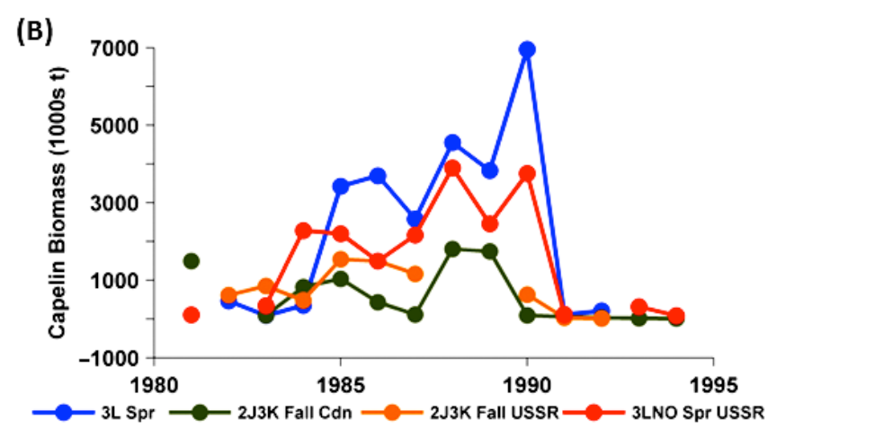

**Fig FM1 – Fig S1b taken from Frank et al.** Biomass estimates from capelin surveys in the NL region compared to the ongoing Div. 3L survey up to 1994.

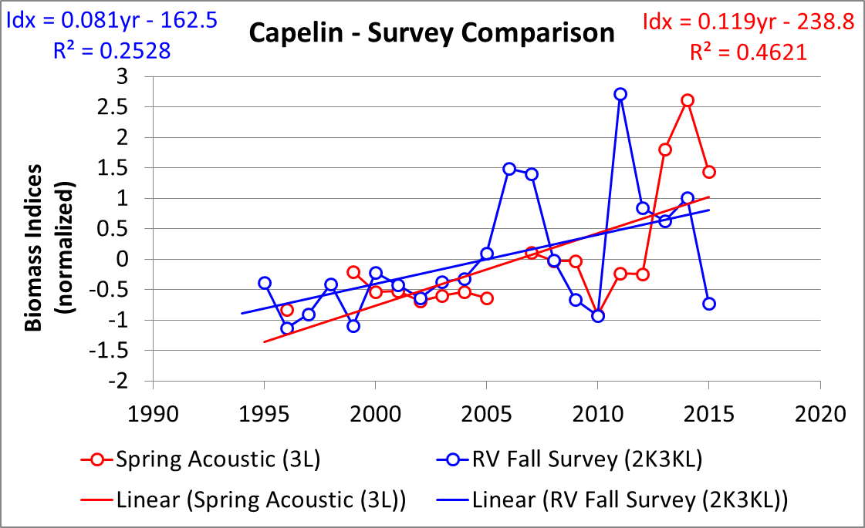

Fig FM2 – Temporal trends in spring acoustic and bottom trawl abundance estimates from 1995-2015.



Fig FM3 – Age composition by Nafo Division of capelin captured in fall 2J3K(L) acoustic surveys and in Campelen Fall 2J3KL bottom trawl surveys during period of different spring abundance index levels.

Figure FM4– Age composition of capelin found in the spring 3L acoustic survey from 1985-2015. Hatched bars indicate immature individuals. (2015 assessment excel)



**A**

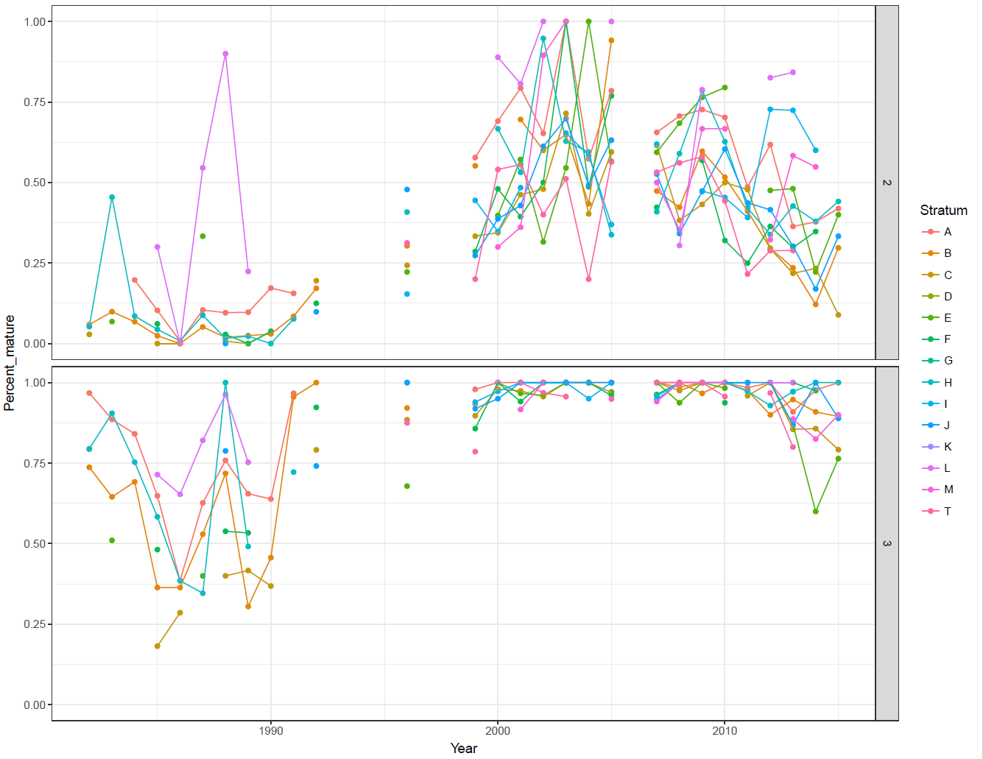

**B**

Figure FM5 - NAFO Division 3L with stratum boundaries used during spring acoustic capelin survey indicated (A); the proportion of maturing capelin by age (2- upper, 3 lower) and survey stratum as observed during surveys from 1985-2015 (**B**).



Figure FM-6 Inshore seasonal survey site Trinity Bay indicating the postion of acoustic transects (solid lines) and 100, 200 and 500 depth contours (dashed lines).

Figure FM-7 –Maturity stage composition (Upper) and age composition (lower) of capelin sampled in Trinity Bay during sesasonal surveys 2002 -2007.

Fig FM-8 Seasonal biomass trends in Trinity Bay September 2003 – Sep 2005. Note May values are for the Main Bay portion only, all others are for the complete Bay. Biomass estimates were not available for April surveys.

Figure FM-9 Offshore acoustic index (red diamonds) and Trinity Bay May acoustic index (blue diamonds) from May surveys conducted 1998-2017. Dashed grey line indicate 95% confidence limits indices.